ANSUR II Anthropometric Measures Data Analysis
Jesse Evans
March 3, 2026
University of Utah
PBHLT 6101: Data Management, Analytics, and Health Research
Introduction
The purpose of this analysis is to better understand the anthropometric measurements for personnel representing the US Army force including Active Duty, Reserves, and National Guard. This information is useful to understand sizing, equipment design, and tariffing applications, among other uses. The source of data comes from the US Army and was captured from 2010-2012 at the Natick Solider Research, Development, and Engineering Center (NSRDEC). There are 29 variables in the dataset, including demographics, work information, and 17 anthropometric measurements related to stature, weight, and trunk circumference. Two variables, height and weight, were captured through both self-reporting and through exact measurement. There are 7,031 total observations in the dataset with 2,183 of those being females and 4,848 of those being men.

Data Analysis Workflow

Step 1
- Create file organizational process
- Review the purpose and the source of the data
- Save raw dataset
- Upload dataset into Stata
- First overview glance at variables and values

Step 2
- Review and become familiar with the codebook
- Start data management/cleaning
  - Labeling
  - Replacing missing values
  - Creating categorical variables
  - Destringing variables
  - Reformatting variables
  - Removing values/variables
  - Make sure measurement variables has consistent units
Step 3
- Produce summary information for the dataset as a whole
- Identify what variables are correlated or can be reasonably compared/analyzed
- Conduct analyses of variables
- Create figures and tables to demonstrate findings
- Write a written description to describe the figures and tables
Step 4
- Make sure all files are saved in their final versions and in the correct place
- Create an organized report and combine all the information into one document
- Double check formatting for tables, figures, and written sections
- Proofread entire report for clarity, accuracy, and consistency

Sample Characteristics
Anthropometric Characteristics
Table 3.1 Anthropometric Measures by Body Part
Variable | Mean | Standard Deviation | Number of Observations | Number of Missing/Suspicious Values
Self-Reported Values
Weight (lbs) | 175.51 | 33.48 | 7027 | 2
Height (in) | 68.35 | 3.85 | 7029 | N/A
Measures of Stature
Thumb Tip Reach (mm) | 802.76 | 282.63 | 7028 | 11
Span (mm) | 1767.86 | 110.50 | 7028 | 1
Foot Length (mm) | 263.43 | 117.32 | 7028 | 1
Knee Height, Midpatella (mm) | 475.32 | 32.89 | 7028 | 1
Waist Height (Omphalion) (mm) | 1032.60 | 62.55 | 7028 | 1
Functional Leg Length (mm) | 1104.31 | 68.09 | 7028 | 1
Cervical Height (mm) | 1479.79 | 84.07 | 7028 | 1
Trochanterion Height (mm) | 882.76 | 54.00 | 7028 | 1
Stature (mm) | 1716.59 | 89.68 | 7028 | 1
Measures of Trunk Circumference
Waist Circumference (mm) | 916.90 | 113.95 | 7028 | 1
Chest Circumference (mm) | 1024.89 | 100.19 | 7028 | 1
Bicristal Breadth (mm) | 274.54 | 19.08 | 7028 | 1
Hip Breadth (mm) | 348.41 | 24.99 | 7028 | 1
Hip Breadth, Sitting (mm) | 385.89 | 32.03 | 7028 | 1
Measured Weight
Weight (kg) | 84.13 | 58.08 | 7028 | 1
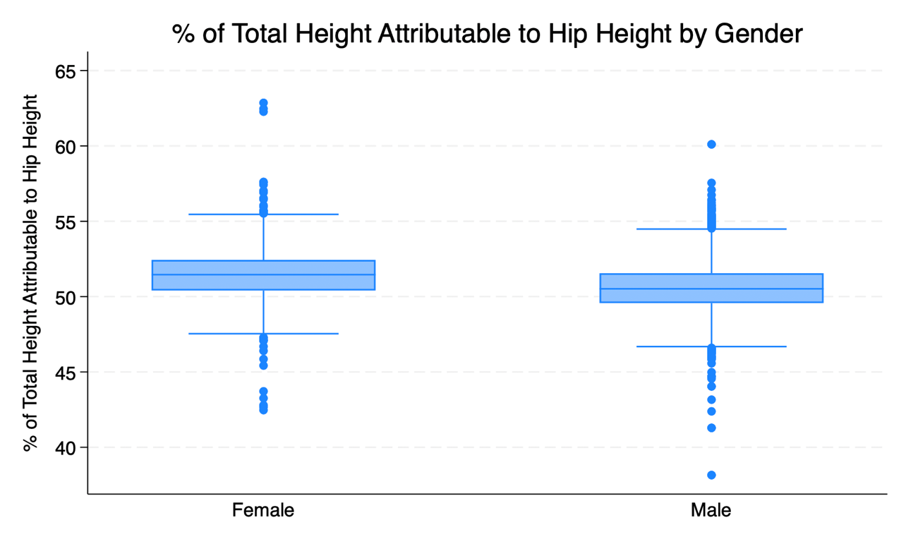
Figure 3.1 Differences in % of Total Height Attributable to Height to Hip by Sex
Measurements for stature (total height) and trochanterion height (height from the ground to the hip), were taken for each participant. A difference in the percent of total heigh attributable to hip height was generated, stratified by gender. The findings, shown in Figure 3.1, were that females tend to have a slightly lower percentage of their height that can be attributed to hip height. This does show that females and males are proportionally different, with males having proportionally longer legs compared to females. This information could be useful when evaluating injury risk, athletic performance, or designs for clothing and equipment fit.
Data Quality Assessment
In conducting data management and cleaning, there were data quality issues that had to be assessed and resolved. One data quality issue were extreme values that did not make sense for the variable. For example, there were values for the variable of weight that were inputted as zero. Having zero for weight is not possible and therefore was handled by replacing it with an indicator that showed it was a missing value. All extreme variables were handled this way.
Another data quality issue was found with the weight (kg) variable. Almost all the values were inputted to the tenth decimal place. There were some abnormal values that were very large; however they did not have decimal points. If those large values were given a decimal point to the tenth place, it made all those inputted values reasonable. It can be assumed that there was an input error for these values in this variable. This was handled by replacing all those extreme values with a new value that was the original value divided by ten.
A third data quality issues were misspellings in the writing preference variable. Some of the values were spelled “either han”, when one of the options was “either hand (no preference)” so it can be assumed that the “either han” values were a cutoff spelling of the latter. To address this, I replaced all the “either han” values with the same spelling of “either hand (no preference)” so they would match appropriately.

Relationships Between Anthropometric Measures
Relationship Between Measures of Stature
In comparing the correlation between stature (total height) and other measures of stature, cervical height was the most correlated measure. As seen in Figure 4.1, we can see that the correlation is very strong as there is a straight positive linear relationship. In assessing this, the cervical height being the most strongly correlated with stature, is a reasonable conclusion as cervical height is almost the entirety of stature. This means that there is less room for variability in correlation. For other measures such as trochanterion height, there is still room for variation in relationship because tronchanterion height is significantly less of the total height percentage than cervical height.
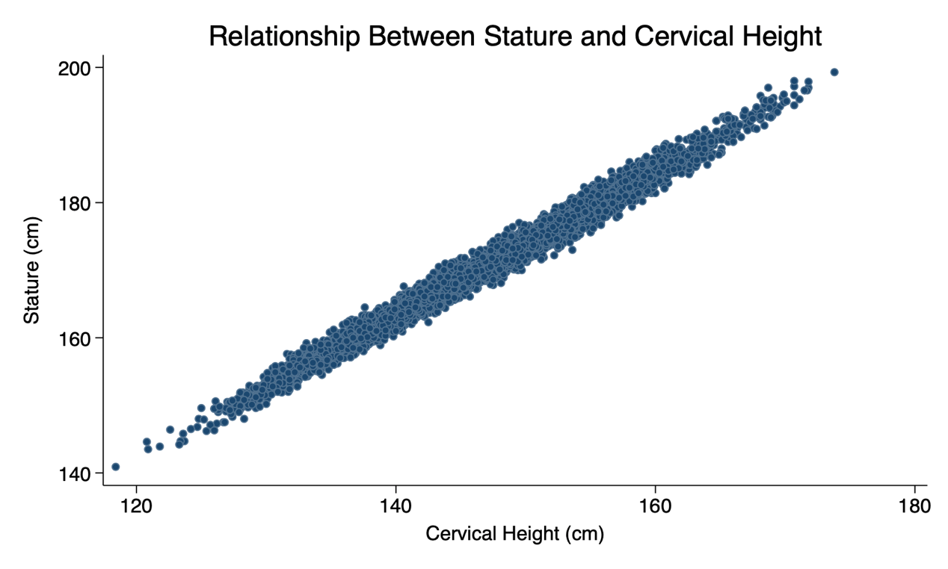
Figure 4.1 Relationship Between Most Highly Correlated Stature Measures (Stature and Cervical Height)
Eight measures of stature were taken along with a direct measure for stature, which indicated total height. In conducting an analysis, correlation strengths between those measures of stature and stature, by gender, were generated. It was found that among both women and men, cervical height was the most correlated measure with stature. This can be attributed to the fact that cervical height is almost the entire length of a participant’s stature, therefore less variation would be likely to occur. An interesting finding was that thumb tip reach was the least correlated with stature, but the span was significantly more correlated even those these two measurements are measuring similar aspects (elements of arm length and span). Most did tend to be correlated, with no measurement showing little correlation.
Table 4.1 Correlation Between Overall Height (Stature) and Other Measures of Stature by Gender
Measure of Stature | Correlation for Women (r) | Correlation for Men (r)
Thumb Tip Reach (mm) | 0.67 | 0.69
Span (mm) | 0.82 | 0.82
Foot Length (mm) | 0.73 | 0.72
Knee Height, Midpatella (mm) | 0.84 | 0.83
Waist Height (Omphalion) (mm) | 0.91 | 0.91
Functional Leg Length (mm) | 0.83 | 0.81
Cervical Height (mm) | 0.98 | 0.98
Trochanterion Height (mm) | 0.86 | 0.85

Relationship Between Actual and Reported Height and Weight
In this dataset, weight that was self-reported was collected along with an actual measurement of weight taken by the data collectors. In Figure 4.2 - 1, we can see the comparison between self-reported weight and measured weight. As we can see, the two variables are very similar in their distributions. The measured weight skews slightly higher but not significantly enough to determine a significant difference. This information is beneficial as it shows that self-reported weight can be used as a proxy to actual measured weight when self-reported may be more feasible to capture.
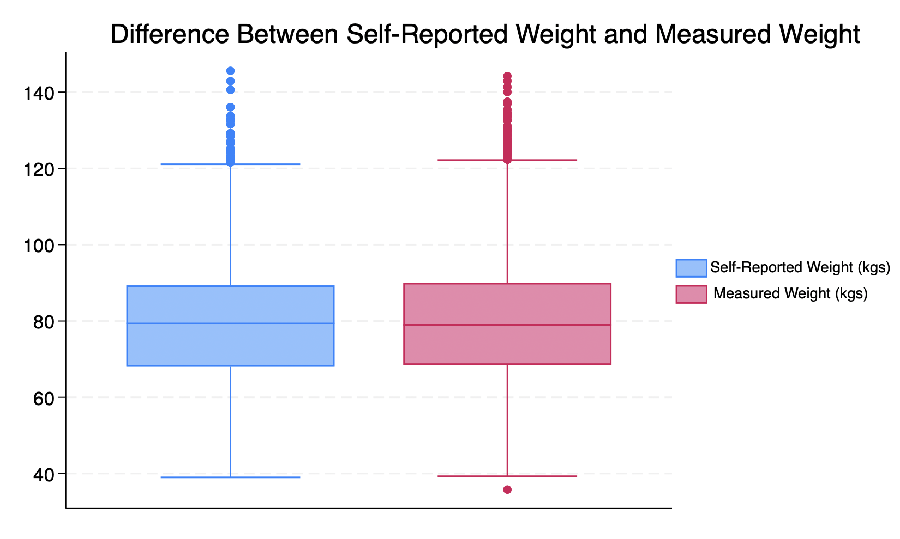
Figure 4.2 – 1 Difference in Self-Reported Weight and Measured Weight
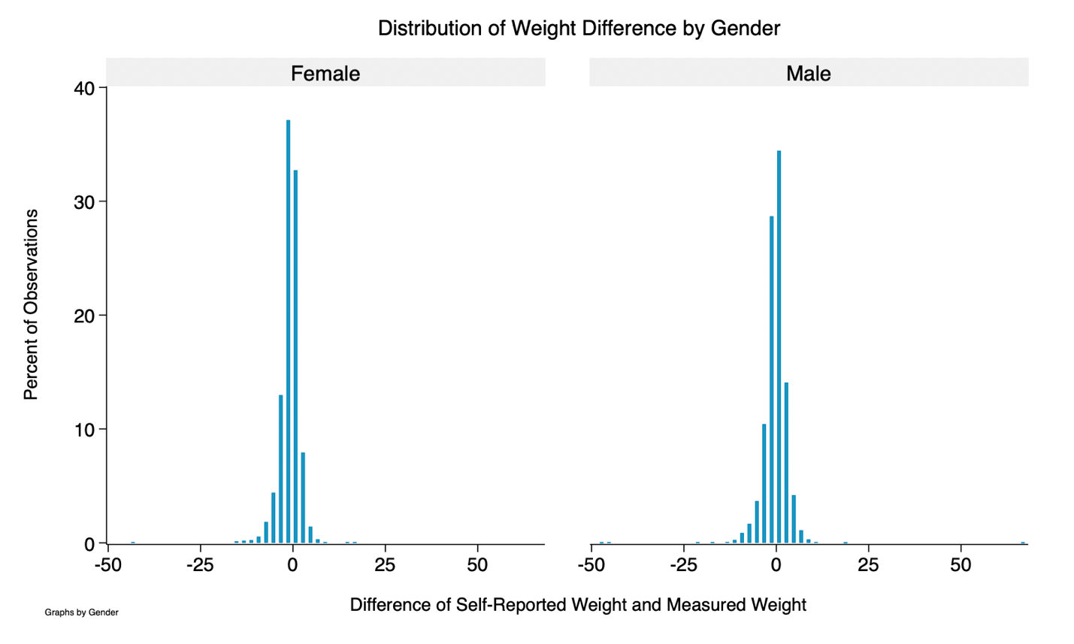
Figure 4.2 – 2 Difference in Self-Reported Weight and Measured Weight, by Sex
In the data collection process, two measurements were taken for height. One measurement was a self-reported measurement given by each participant. The second measurement was a measurement that was taken by the data collector. To understand the difference between the two indicators, we compared the two variables using a box and whiskers plot as shown in Figure 4.2 - 3. The figure shows that the self-reported measurements tend to be slightly higher than the values that were measured, including a few self-reported outliers that are a lot higher than the stature measurements. Overall, there is not significant difference the two measurements. This is beneficial to know as self-reporting may be the more feasible option at times, which can still be useful. It is also informative that there is a benefit of accuracy to having data collectors measure participants themselves instead of relying on self-reporting.
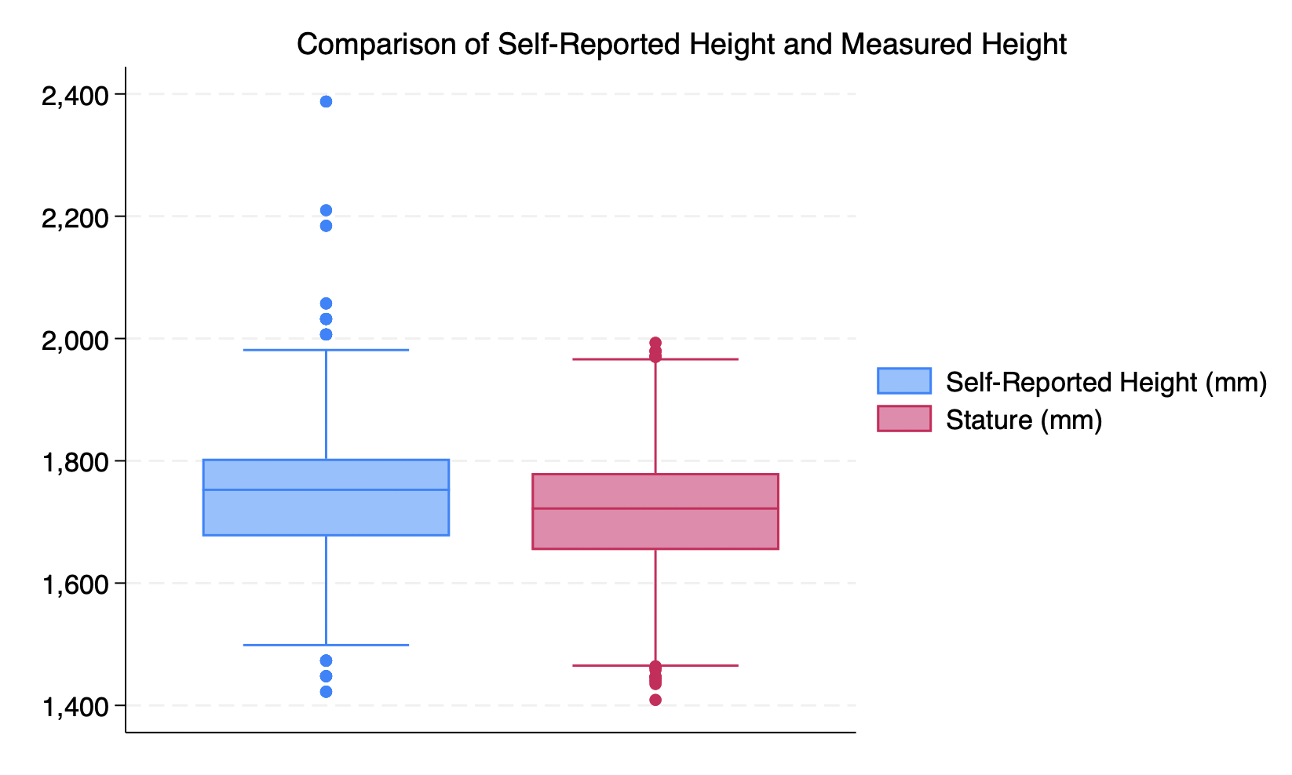
Figure 4.2 – 3 Difference in Self-Reported Height and Measured Height
Comparing self-reported and actual weight and height brings up the discussion of how bias can play into data. With weight, the self-reported information tended to be less than what was measured. This could be due to a social desirability bias, meaning that an individual prefers to be seen at a lower weight than what the actual measurement is. This same issue can be happening with height as the self-reported heights tended to be higher than the actual height measurements.

Relationship Between Derived Body Type and Weight/BMI
Table 4.3 Distributions of Weight and BMI by Body Type
Body Type | Weight (kg) | Body Mass Index
Female - Lean
Mean | 51.83 | 17.47
Standard Deviation | 7.62 | 1.15
Number of Obs. | 26 | 26
Female - Moderate
Mean | 80.25 | 27.03
Standard Deviation | 22.66 | 5.23
Number of Obs. | 2162 | 2160
Female - Heavy Build
Mean | 73.67 | 26.92
Standard Deviation | 7.86 | 1.31
Number of Obs. | 828 | 828
Female - Very Heavy Build
Mean | 85.67 | 32.01
Standard Deviation | 9.86 | 1.83
Number of Obs. | 143 | 143
Male - Lean
Mean | 65.18 | 17.22
Standard Deviation | 15.52 | 1.36
Number of Obs. | 26 | 26
Male - Moderate
Mean | 72.42 | 22.85
Standard Deviation | 8.18 | 1.48
Number of Obs. | 1431 | 1431
Male - Heavy Build
Mean | 86.62 | 27.28
Standard Deviation | 8.75 | 1.43
Number of Obs. | 2412 | 2413
Male - Very Heavy Build
Mean | N/A | N/A
Standard Deviation | N/A | N/A
Number of Obs. | 0 | 0

The derived body types as classified with weight (kg) and BMI, show that most of the individuals, both male and female, were moderate or heavy builds. In particular, females were highest among the moderate build type while men were highest among the heavy build. Relatively few were listed as lean or very heavy build for either gender. This comparison does reflect an assumption that less people would fall on either the low or high end of BMI, especially given a U.S. Army background where physical activity is common. The high numbers in moderate and heavy build categories does bring up the potential for further understanding of these categories. Understanding the data more specifically those ranges could be interesting to see where most individuals lie.

References
Hotzman, Jennifer, et al. MEASURER’S HANDBOOK: US ARMY and MARINE CORPS ANTHROPOMETRIC SURVEYS, 2010-2011. 2010.

Appendix
Stata Code
**PBHLT6101
**Project 1 - ANSUR
**Jesse Evans
**February 19, 2026

**ANSUR II Dataset - Anthropometric Data for US Army members

********************************************************************************

***PART 1: IMPORT DATA***

*Set working directory
cd "/Users/jesseevans/Documents/Stata/Project 1"

clear
use "/Users/jesseevans/Downloads/ansur2allV2.dta"

********************************************************************************

***PART 2 - DATA PREPARATION***

***MISSING VALUES
foreach var in subjectnumericrace dodrace age weightlbs heightin thumbtipreach span footlength kneeheightmidpatella waistheightomphalion functionalleglength cervicaleheight trochanterionheight stature waistcircumference chestcircumference bicristalbreadth hipbreadth hipbreadthsitting weightkg{

replace `var' = .a if `var' == -77 //not recorded
replace `var' = .b if `var' == -88 //refused measurement
replace `var' = .c if `var' == -99 //unknown missing
}

***SUSPECT AND UNREASONABLE VALUES

**SubjectNumericRace
tab subjectnumericrace // to inspect the variables
tostring subjectnumericrace, replace
gen race_white = strpos(subjectnumericrace, "1") > 0
gen race_black = strpos(subjectnumericrace, "2") > 0
gen race_hispanic = strpos(subjectnumericrace, "3") > 0
gen race_asian = strpos(subjectnumericrace, "4") > 0
gen race_nativeamerican = strpos(subjectnumericrace, "5") > 0
gen race_pacificislander = strpos(subjectnumericrace, "6") > 0
gen race_other = strpos(subjectnumericrace, "8") > 0

**DoDRace
tab dodrace // to inspect the variables
replace dodrace = .x if dodrace == 7 //suspicious/unreasonable value
replace dodrace = .x if dodrace < 1 //suspicious/unreasonable value
replace dodrace = .x if dodrace > 8 //suspicious/unreasonable value

**Ethnicity
tab ethnicity
replace ethnicity = ".x" if ethnicity == ""

**Gender // no suspect values

**Age
tab age // to inspect values
drop if age < 18 // QUESTION 2. This is to indicate anyone who is under 18 years of age without getting rid of the data.

**Component
tab component // values look normal - no suspect or unreasonable

**Branch
tab branch // values look normal - no suspect or unreasonable

**Writing Preferred Hand
replace writingpreference = "Either hand (No preference)" if writingpreference == "Either han" // edited this to replace values that were mistyped

**Installation
tab installation // values look normal - no suspect or unreasonable. All are "Fort" or "Camp"

**Test Date
tab test_date // values look normal - no suspect or unreasonable

**Weight lbs
tab weightlbs
replace weightlbs = .x if weightlbs == 0 // a person cannot be 0 lbs

**Height (Inches)
tab heightin // potentially some suspect values of 57-58 and 94 but they are not suspect enough for me to want to do anything with them yet.

summ thumbtipreach span footlength kneeheightmidpatella waistheightomphalion functionalleglength cervicaleheight trochanterionheight stature waistcircumference chestcircumference bicristalbreadth hipbreadth hipbreadthsitting weightkg date

**Thumb Tip Reach (mm)
tab thumbtipreach
replace thumbtipreach = .x if thumbtipreach > 999 // the reasonable range for thumb tip range for half arm span is 600-900 so the data above 998 at 7000-9500mm are unreasonable.

**Span (mm)
tab span // all seem reasonable. For span, a typical range is 1300-2200mm which all values fall within.

**Foot Length (mm)
tab footlength // all seem reasonable. For footlength, a typical range is 200-320mm which the values either fall within or are close enough to not want to take out.

**Knee Height, Midpatella (mm)
summ kneeheightmidpatella
tab kneeheightmidpatella // all seem reasonable. A typical range is 400-650mm which the values either fall within or are close enough to not want to take out.

**Trochanterion Height (mm)
summ trochanterionheight
tab trochanterionheight // all seem reasonable. A typical range is 650-1100mm and all the values either fall within or are close enough to not want to mark as suspicious/unreasonable.

**Waist Height (Omphalion) (mm)
summ waistheightomphalion
tab waistheightomphalion // all seem reasonable. A typical range is 800-1200mm and all the values either fall within or are close enough to not want to mark as suspicious/unreasonable.

**Functional Leg Length (mm)
summ functionalleglength
tab functionalleglength // all seem reasonable. A typical range is 700-1150mm and all the values either fall within or are close enough to not want to mark as suspicious/unreasonable.

**Cervial Height (mm)
summ cervicaleheight
tab cervicaleheight // all seem reasonable. A typical range is 1100-1750mm and all the values either fall within or are close enough to not want to mark as suspicious/unreasonable.

**Stature (mm)
summ stature
tab stature // all seem reasonable. A typical range is 1350-2100mm and all the values either fall within or are close enough to not want to mark as suspicious/unreasonable.

**Waist Circumference (mm)
summ waistcircumference
tab waistcircumference // all seem reasonable. A typical range is 500-1500mm and all the values either fall within or are close enough to not want to mark as suspicious/unreasonable.

**Chest Circumference (mm)
summ chestcircumference
tab chestcircumference // all seem reasonable. A typical range is 700-1400mm and all the values either fall within or are close enough to not want to mark as suspicious/unreasonable.

**Bicristal Breadth (mm)
summ bicristalbreadth
tab bicristalbreadth // all seem reasonable. A typical range is 200-380mm and all the values either fall within or are close enough to not want to mark as suspicious/unreasonable.

**Hip Breadth (mm)
summ hipbreadth
tab hipbreadth // all seem reasonable. A typical range is 250-450mm and all the values either fall within or are close enough to not want to mark as suspicious/unreasonable.

**Hip Breadth, Sitting (mm)
summ hipbreadthsitting
tab hipbreadthsitting // all seem reasonable. A typical range is 250-500mm and all the values either fall within or are close enough to not want to mark as suspicious/unreasonable.

**Weight in kg
summ weightkg
tab weightkg
replace weightkg = weightkg/10 if weightkg > 500 // these values did not have a decimal, while almost all the others did. These were also extremely high but made sense if they were just missing the decimal point so I made the assumptions that I could change them. A typical range is 35-200kg.

***DUPLICATES
duplicates list // "duplicates in terms of all variables - 0 observations are duplicates" // QUESTION 3
duplicates examples // "0 observations are duplicates"

***LABEL ALL VARIABLES AND VALUES OF CATEGORICAL VARIABLES

**label all variables
label variable subjectnumericrace "Subject Numeric Race"
label variable dodrace "Department of Defense Race"
label variable ethnicity "Ethnicity"
label variable gender "Gender"
label variable age "Age"
label variable component "Component"
label variable branch "Branch"
label variable writingpreference "Writing Preference"
label variable installation "U.S. Army Installation"
label variable test_date "Test Date"
label variable weightlbs "Weight in Pounds (lbs)"
label variable heightin "Height in Inches"
label variable thumbtipreach "Thumbtip Reach"
label variable span "Span"
label variable footlength "Foot Length"
label variable kneeheightmidpatella "Knee Height, Midpatella"
label variable waistheightomphalion "Waist Height (Omphalion)"
label variable functionalleglength "Functional Leg Length"
label variable cervicaleheight "Cervical Height"
label variable trochanterionheight "Trochanterion Height"
label variable stature "Stature"
label variable waistcircumference "Waist Circumference (Omphalion)"
label variable chestcircumference "Chest Circumference"
label variable bicristalbreadth "Bicristal Breadth"
label variable hipbreadth "Hip Breadth"
label variable hipbreadthsitting "Hip Breadth, Sitting"
label variable weightkg "Weight in Kilograms (kgs)"
label variable date "Date of Measurement"
label variable strdate "String Date"
label variable race_white "Race - White"
label variable race_black "Race - Black"
label variable race_hispanic "Race - Hispanic"
label variable race_asian "Race - Asian"
label variable race_nativeamerican "Race - Native American"
label variable race_pacificislander "Race - Pacific Islander"
label variable race_other "Race - Other"

**CONVERT FROM MM TO CM
foreach var in thumbtipreach span footlength kneeheightmidpatella waistheightomphalion functionalleglength cervicaleheight trochanterionheight stature waistcircumference chestcircumference bicristalbreadth hipbreadth hipbreadthsitting {

gen `var'_cm = `var'
replace `var'_cm = `var' / 10
}

label variable thumbtipreach_cm "Thumbtip Reach (cm)"
label variable span_cm "Span (cm)"
label variable footlength_cm "Foot Length (cm)"
label variable kneeheightmidpatella_cm "Knee Height, Midpatella (cm)"
label variable waistheightomphalion_cm "Waist Height (Omphalion) (cm)"
label variable functionalleglength_cm "Funcational Leg Length (cm)"
label variable cervicaleheight_cm "Cervical Height (cm)"
label variable trochanterionheight_cm "Trochanterion Height (cm)"
label variable stature_cm "Stature (cm)"
label variable waistcircumference_cm "Waist Circumference (cm)"
label variable chestcircumference_cm "Chest Circumference (cm)"
label variable bicristalbreadth_cm "Bicristal Breadth (cm)"
label variable hipbreadth_cm "Hip Breadth (cm)"
label variable hipbreadthsitting_cm "Hip Breadth Sitting (cm)"

***NEW VARIABLES

**b) Continuous BMI Variable
gen bmi_cont = (weightlbs*703) / (heightin * heightin) //this is the formula for calculating bmi

gen bmi_cat = .
replace bmi_cat = .x if bmi_cont == 0
replace bmi_cat = 1 if bmi_cont > 0 & bmi_cont < 18.5
replace bmi_cat = 2 if bmi_cont >= 18.5 & bmi_cont <25
replace bmi_cat = 3 if bmi_cont >= 25 & bmi_cont < 30
replace bmi_cat = 4 if bmi_cont >= 30

label variable bmi_cat "BMI Category"
label define bmi_labels .x "Out of Range/Suspicious" 1 "Underweight" 2 "Normal Weight" 3 "Overweight" 4 "Obese"
label values bmi_cat bmi_labels

**c)Variable for Season
gen month = month(date)

gen season = .
replace season = 1 if inlist(month, 11, 12, 1, 2)
replace season = 2 if inlist(month, 3, 4, 5)
replace season = 3 if inlist(month, 6, 7, 8)
replace season = 4 if inlist(month, 9, 10)

label variable season "Season"
label define season_labels 1 "Winter" 2 "Spring" 3 "Summer" 4 "Fall"
label values season season_labels

**d) Numerical Categorical Variable for Gender and Preferred Hand
tab gender // this is to understand the values
tab writingpreference // this is to understand the values

encode gender, gen(gender_cat)
codebook gender //Male = 2, Female = 1

encode writingpreference, gen(prefhand_cat)
codebook prefhand_cat // Either = 1, Left = 2, Right = 3

label variable bmi_cont "BMI (Continuous)"
label variable month "Month"
label variable gender_cat "Gender (Category)"
label variable prefhand_cat "Preferred Hand (Category)"

**e)BODY TYPES
gen body_type = .
replace body_type = 1 if gender_cat == 1 & bmi_cat == 1
replace body_type = 2 if gender_cat == 1 & bmi_cat == 2
replace body_type = 3 if gender_cat == 1 & bmi_cat == 3
replace body_type = 4 if gender_cat == 1 & bmi_cat == 4
replace body_type = 5 if gender_cat == 2 & bmi_cat == 1
replace body_type = 6 if gender_cat == 2 & bmi_cat == 2
replace body_type = 7 if gender_cat == 2 & bmi_cat == 3
replace body_type = 2 if gender_cat == 2 & bmi_cat == 4

label variable body_type "Body Type"
label define bodytype_labels 1 "Female - Lean" 2 "Female - Moderate Build" 3 "Female - Heavy Build" 4 "Female - Very Heavy Build" 5 "Male - Lean" 6 "Male - Moderate Build" 7 "Male - Heavy Build" 8 "Male - Very Heavy Build"
label values body_type bodytype_labels

********************************************************************************

***PART 3: SAMPLE CHARACTERISTICS***

**3.1 Anthropometric characteristics

**a)
tabstat weightlbs heightin thumbtipreach span footlength kneeheightmidpatella waistheightomphalion functionalleglength cervicaleheight trochanterionheight stature waistcircumference chestcircumference bicristalbreadth hipbreadth hipbreadthsitting weightkg, statistics(mean sd n) columns(statistics)

misstable summarize weightlbs heightin thumbtipreach span footlength kneeheightmidpatella waistheightomphalion functionalleglength cervicaleheight trochanterionheight stature waistcircumference chestcircumference bicristalbreadth hipbreadth hipbreadthsitting weightkg

**b)
gen height_hip_ratio = ((trochanterionheight_cm/2.54) / heightin) * 100
label variable height_hip_ratio "% of Total Height Attributable to Hip Height"

tabstat height_hip_ratio, by(gender) stat(mean sd n)

graph box height_hip_ratio, over(gender)

*graph bar (mean) height_hip_ratio, over(gender) // other option

*graph bar (height_hip_ratio), over(gender) //showing "invalid stat"

********************************************************************************

***PART 4: RELATIONSHIPS BETWEEN ANTHROPOMETRIC MEASURES***

**4.1 Relationship between measures of stature
**a)

pwcorr stature_cm kneeheightmidpatella_cm cervicaleheight_cm trochanterionheight_cm waistheightomphalion_cm functionalleglength_cm footlength_cm thumbtipreach_cm span_cm

twoway (scatter stature_cm cervicaleheight_cm) // these two had the highest correlation at 0.9911. Edited the graph titles, color, etc. through the graph editor.

**b)

by gender, sort: pwcorr stature kneeheightmidpatella_cm cervicaleheight_cm trochanterionheight_cm waistheightomphalion_cm functionalleglength_cm footlength_cm thumbtipreach_cm span_cm

**4.2 Relationship between actual and reported height and weight
**a)

gen selfrep_weight = weightlbs / 2.205
label variable selfrep_weight "Self-Reported Weight (kg)"
graph box selfrep_weight weightkg // made edits in the graph editor

**b)
gen weight_diff = selfrep_weight - weightkg
label variable weight_diff "Difference in Self-Reported Weight and Measured Weight"
summ weight_diff, detail

histogram weight_diff, percent width(2) by(gender) ///
title("Distribution of Weight Difference by Gender") ///
xtitle("Self - Measured Weight (kg)") // Made edits inthe graph editor

**c)
gen selfrep_height = heightin * 25.4
label variable selfrep_height "Self-Reported Height (mm)"
graph box selfrep_height stature // made edits in the graph editor.

tabstat weightkg bmi_cont, by(body_type) statistics(mean sd n)
tab body_type bmi_cat, row

**end of code

